**EDA Report: Quick View Of Price Surge in Nigeria Using Data Science**

This report provides an in-depth analysis of Nigeria's economic and demographic trends from 1960 onwards, focusing on key sectors, population dynamics, inflation trends, and the interplay between petrol prices and economic performance.

**1. GDP Insights: (1960 Onwards)**

GDP in Constant and Current LCU

* Correlation: The GDP in constant and current Local Currency Units (LCU) shows a very high correlation (0.994), indicating consistency in GDP measurements over time.
* Trend: A significant upward trend in GDP highlights sustained economic growth in Nigeria over the years.

GDP per Capita and Growth

* Correlation: GDP per capita (current US$) and GDP per capita growth (annual %) show a moderate positive correlation (0.501), suggesting a relationship between overall economic output and individual income growth.

**2. Population Dynamics**

Total, Female, and Male Populations

* Correlation: Strong correlations exist between the total, female, and male populations, indicating consistent growth across all demographic segments.

Age Groups

* Correlation: There is a strong negative correlation (-0.992) between the proportions of young (ages 0-14) and working-age (ages 15-64) populations, indicating an inverse relationship.
* Trend: Steady population growth from 1960 onwards, with annual growth rates around 2% for both male and female populations.

**3. Petrol Prices and GDP**

* Correlation: Petrol prices in Naira show a positive correlation with GDP in US dollars (0.229) and per capita GDP (0.286), suggesting a relationship between energy prices and economic performance.
* Trend: Petrol prices have seen a steady increase, particularly from the late 1990s onwards, correlating with global oil price changes and domestic policy adjustments.

**4. Inflation Trends**

* 1981: Extremely high inflation rates following the global oil price collapse.
* 1988-1989: High consumer price inflation, reflecting economic instability.
* 1992-1995: Persistent high inflation due to structural adjustment programs and economic reforms.

## **5. Financial and Monetary Indicators**

### Total Reserves: A significant increase in total reserves over the years, indicating improved accumulation of foreign exchange and gold reserves.

### Narrow Money and Money Supply (M3): Both metrics show noticeable upward trends, reflecting increased monetary circulation.

## **6. Credit to Private Sector**

### Credit Growth: Steady increase in credit extended to the private sector, indicating growth in private sector activities and investments.

## **7. Oil Sector Insights**

### Crude Oil Prices: Considerable volatility with significant peaks and troughs in crude oil prices.

### Cumulative Production: Clear upward trend in cumulative crude oil production, indicating continuous increase in oil extraction activities over time.

**GDP by Sectors (FROM 1980 Onwards and Real GDP):**

**Real GDP Variability Analysis by Economic Sector**

## Services: Highest standard deviation (approximately 12736.28).

## Agriculture: Second highest standard deviation (approximately 5866.18).

## Crop Production: Standard deviation around 5401.48.

## Industry: Standard deviation approximately 2491.22.

## Crude Petroleum and Natural Gas: Standard deviation about 1458.80.

## Mining and Quarrying: Standard deviation approximately 1448.67.

## Livestock: Standard deviation around 310.52.

## Fishing: Standard deviation about 117.02.

## Forestry: Standard deviation approximately 41.89.

## Coal Mining: Lowest standard deviation approximately 7.43.

**Sectoral Trends Over Time:**

* Agriculture Trend: Gradual, moderate, but steady growth.
* Industry Trend: Relatively flat with minor fluctuations, slight increase in the early 2000s.
* Services Trend: Substantial growth, especially from the early 2000s, closely following the overall GDP trend.

### Manufacturing: shows variability, with periods of increase and decrease.

### Construction Sector: Substantial growth, particularly post-2000.

### Information and Communication Sector: Significant growth, especially from the early 2000s.

### Real Estate: Steady increase in value, mirroring trends in urbanization and real estate development.

* Crop Production: Noticeable upward trend, particularly from the mid-1990s onwards, indicating increased agricultural productivity or expanded agricultural activities.
* Livestock: Gradual increase with some fluctuations.

## **Correlation Heatmap:**

## GDP at 2010 Constant Market Prices: Strong positive correlations with Agriculture, Crop Production, Livestock, Forestry, Fishing, and Services.

## Coal Mining: Negative correlation with GDP.

## Mining and Quarrying, and Crude Petroleum and Natural Gas: Weaker correlations, indicating less direct impact on GDP.

## **Monetary Policy**

* Maxima: Reached a value of 26.25 on 2024-05.
* Minima: Value of 6.00 was reached on 2009-07.
* Local Maxima: Seen around 1994.
* Recent Trend: Sharp increase in recent years.
* Fluctuations: Not very continuous, showing sharp rises and falls with an apparent overall periodicity.

**Debt and Unemployment (1990 Onwards)**

* **Debt and Unemployment**: There is a weak positive relationship between debt and unemployment, suggesting that higher national debt might be associated with slightly higher unemployment rates.
* **Debt and Export Rate**: There is a weak negative relationship between debt and export rate, indicating that higher debt levels might be slightly associated with lower net export rates as a percentage of GDP.
* **Unemployment and Export Rate**: There is a moderate positive relationship between the unemployment rate and export rate, suggesting that higher unemployment rates tend to coincide with higher export rates as a percentage of GDP.

**Unemployment Rate**

* The overall unemployment rate saw a significant increase after 2020. This rise is likely due to the global economic effects of the COVID-19 pandemic, which led to widespread job losses and economic disruptions.
* Similar to the overall trend, the male unemployment rate also experienced a notable increase after 2020, reflecting the impact of the pandemic. While the rate for males is generally lower than for females, the post-2020 spike indicates that men were also significantly affected by the economic downturn.
* The female unemployment rate demonstrated a marked increase after 2020, even more so than the male rate, highlighting the gender disparity. The greater impact on females could be attributed to several factors, such as higher representation in industries most affected by the pandemic.

**EDA Report on Interbank Call Rate**

Data Context:

**Interbank rates** are the exchange rates used by banks and large financial institutions for large transactions; also known as the mid-market rate, spot rate, or real exchange rate, refer to the exchange rate used by banks and large financial institutions when trading large volumes of foreign currency with each other.

Our objective will be to better understand the interbank call rate in correlation to the price surge in the Nigerian Economy. There are additional factors that lead to our better understanding of the interbank call rate, such as the Monthly Payment Rate(MPR), Deposits (1,3,6,12 Months), Prime Lending Rates, and Max Lending Rates.

Monthly payment rate (MPR) is the amount of money an individual or entity pays each month to service a loan/debt. Prime Lending Rate is the interest rate that commercial banks charge their most creditworthy customers for short-term loans. Max Lending Rate is the maximum interest rate that a lender can charge on a given loan/debt.

Central bank policies, Economic indicators, Creditworthiness of Borrowers and Reserve Requirements factor towards Interbank Call Rates between banks and ultimately goes in tandem with the willingness of banks to tank on risks.

Statistical Breakdown of Columns within Dataset:

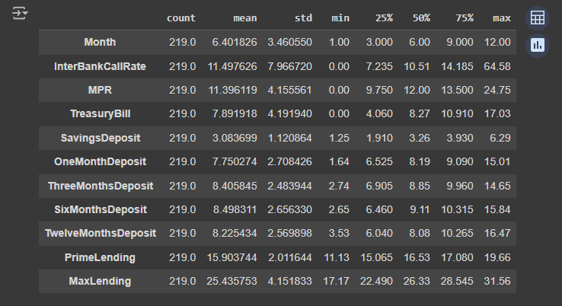

As we can see, the average Interbank Call Rate is 11.5% across the entire date range within the dataset (2006-2024).

* The median Interbank Call Rate is 10.5%.
* The highest Interbank Call Rate within our dataset appears to be 64.58%.

Histogram Observations:

* An indicator of the Mean being larger than the median displays the right skewed distribution.
* There are more extreme outliers such as the 64.58%
* The highest frequency appears to be around 10%
* There are also some gaps, which could be factored by the government to encourage banks to allow borrowing, lowering risks for banks.

Correlation Matrix For Interbank Call Rate

Based on the correlation matrix, Interbank Call Rate is affected mainly by the deposits and the MPR. There has been fluctuations over the years in Interbank Call Rate but currently within 2024, it is currently under 24%. The Interbank Call rate has been gradually increasing since 2020.

**2000 Onwards:**

* In 2006, there was a notable decrease in government debt relative to GDP, reducing by over 50%, indicating substantial fiscal consolidation or reduced borrowing.
* In 2011, There was a significant increase in government debt relative to GDP, rising by over 85%, suggesting increased borrowing, possibly due to economic policies or higher spending needs.
* In 2004, government debt as a percentage of GDP began at 35.49% and decreased to 18.94% by 2005.
* From 2006 to 2008, there was a significant decrease in government debt relative to GDP, reaching a low of 7.28% in 2008.
* Debt increased slightly in 2009 (8.62%) and showed a noticeable increase in 2010 (9.39%) and 2011 (17.43%) following global economic challenges.
* From 2012 onwards, government debt as a percentage of GDP generally increased steadily, with fluctuations. By 2024, it reached approximately 46.59%.

**Monthly Fuel Price:**

1. The distribution is right-skewed.
2. This suggests that while lower prices are more common, there are occasional periods with very high fuel prices. This suggests that while lower prices are more common, there are occasional periods with very high fuel prices.
3. The highest frequency is seen around the 200 Naira per liter range.
4. There are notable gaps between clusters of prices, suggesting periods of stability followed by significant price jumps.